Login Instructions for Staff in FACTS SIS

1. In an Internet browser window, navigate to https://login.renweb.com.

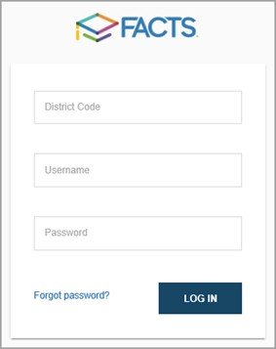

2. Type your school's District Code:
3. Type your Username:
4. Type your Password:

Please Note:

*District Codes and Usernames are not case-sensitive.

*Passwords are case-sensitive, and must include a combination of letters and numbers, and may not include special characters.
5. Click Login.
Accounts are automatically locked after a number of failed log-in attempts. Contact your School Office for assistance.

